Project Work

FrontEnd Engineering



# By - Akarshit Batra

# Roll No. - 2110990113

# Group No. - 5

# Year- 3rd year student(2021 batch)

# Live Link - <https://elector-x.vercel.app/>

# Submitted to - Lavish Arora Sir

# INDEX

# 

| **S No.** | **Section** | **Page No.** |
| --- | --- | --- |
| 1 | Introduction | 3 |
| 2 | Number of Pages | 4 |
| 3 | Technology Used | 25 |
| 4 | Features | 27 |
| 5 | Project Timeline | 30 |
| 6 | Challenges and Solution | 31 |
| 7 | Conclusion | 34 |
| 8 | Resources and Reference | 35 |

# 

# Why did I choose this title Electro-X ?

The title "Electro-X" was chosen for our e-commerce platform for a multitude of compelling reasons. At its core, "Electro-X" reflects our commitment to delivering a state-of-the-art shopping experience for electronic products.

First and foremost, "Electro" derives from "electronics," perfectly encapsulating our specialised focus. Our platform caters exclusively to the dynamic world of electronic gadgets, components, and accessories. By placing "Electro" at the forefront, we make it unmistakably clear that we are the go-to destination for all things electronic.

The addition of "X" signifies a multitude of aspects. It represents the excitement and limitless potential of technology, highlighting our innovative approach. It also suggests the idea of a one-stop destination, where "X" marks the spot for all your electronic needs. Moreover, "X" subtly hints at the exceptional, the extraordinary, and the cutting-edge—qualities we aim to embody in our offerings and user experience.

In summary, the title "Electro-X" was chosen to signify our distinct focus on electronics, our commitment to innovation, and the promise of a comprehensive and exceptional shopping experience. It embodies our mission to provide a platform where customers can explore, discover, and purchase the latest and greatest in the world of electronics.

# Total Number of Pages

* Home Page
* Categories Page
* Sub-Categories Page
* Demo Page
* Login Page
* Sign up Page
* Filter Page(for 6-8k price filter)
* Filter Page(for 10-15k price filter)
* Search Page
* Cart Page
* Checkout Page
* User Profile Page
* New Order Page
* Order History Page
* Transactions Page
* Wishlist Page
* Profile Settings Page
* Comparison Page
* About Us Page
* Frequent Question/Answer Page

# Home Page

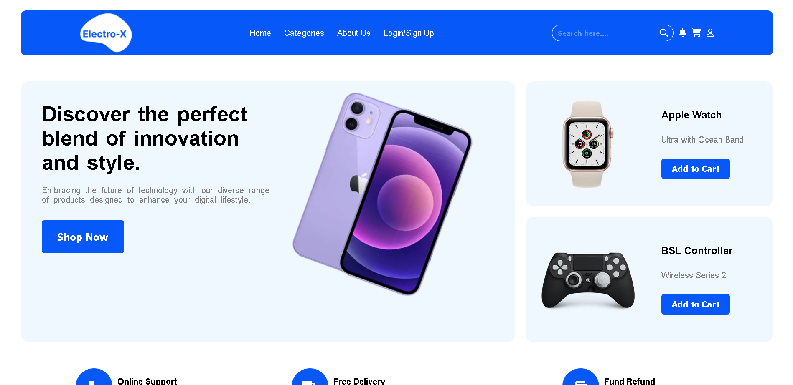

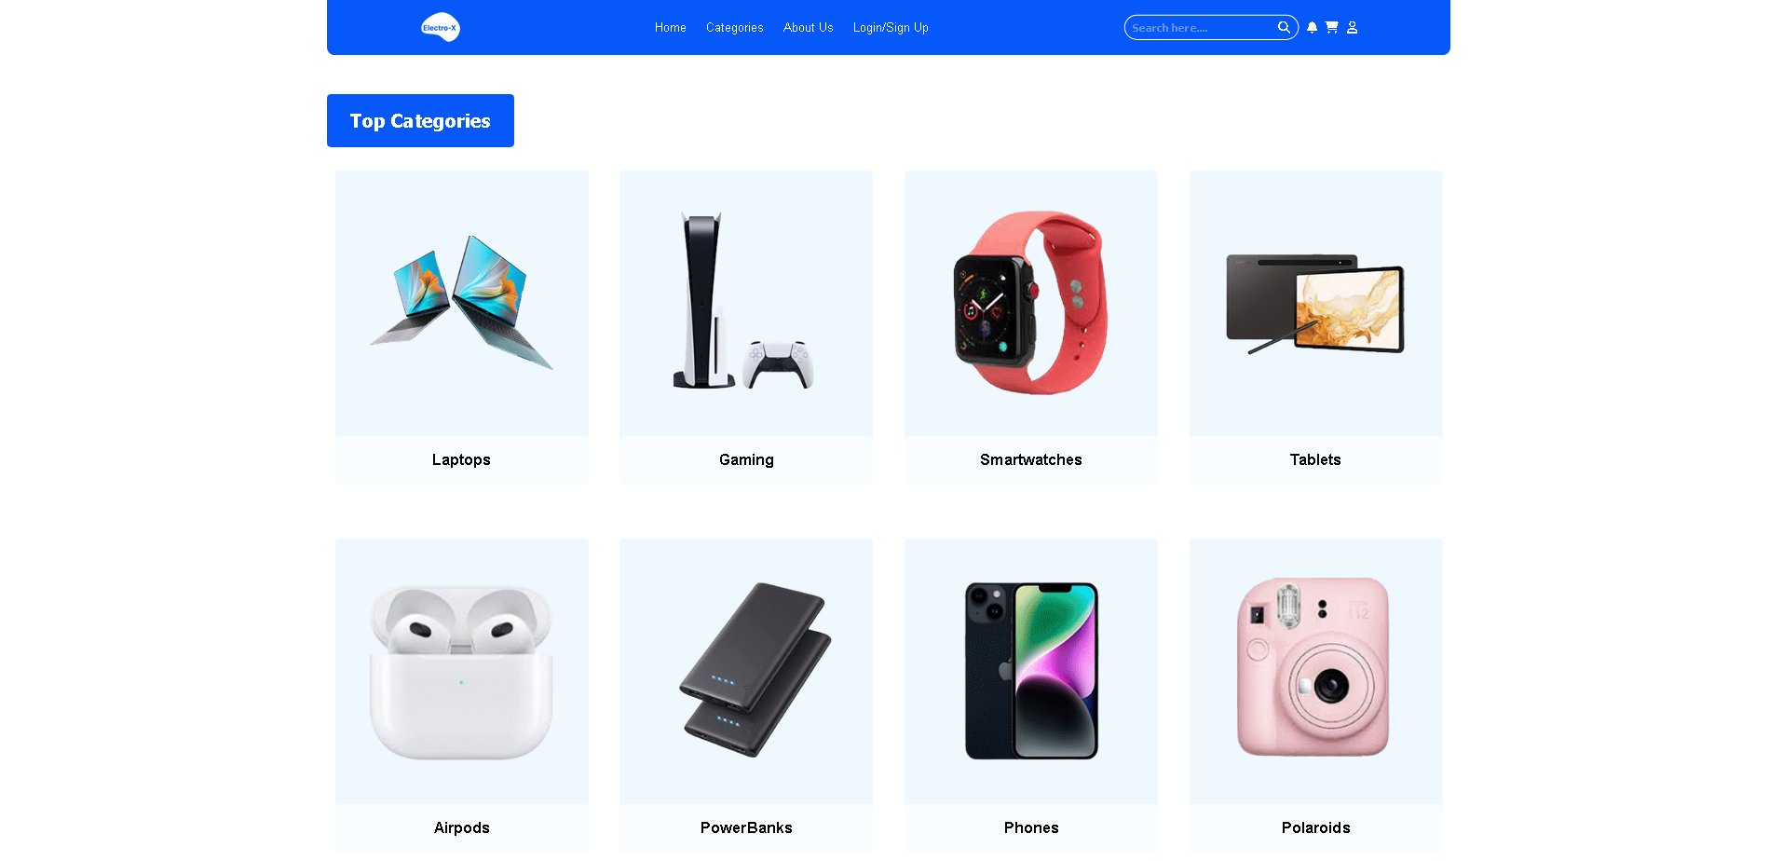



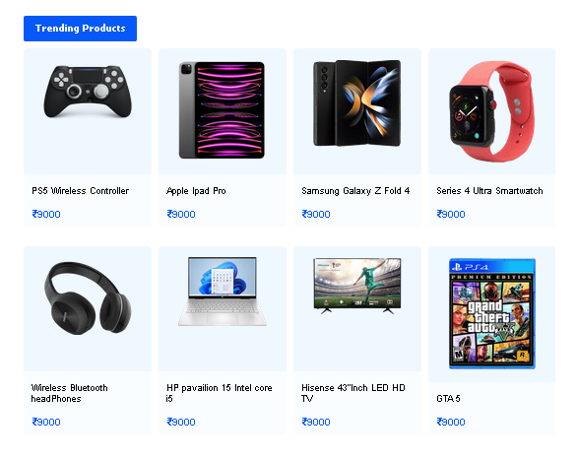

The Electro-X homepage is designed to be a dynamic gateway to an electrifying shopping experience. At the forefront, the display section showcases the latest and greatest electronic products, enticing visitors with a glimpse of what's trending. Our top categories section simplifies navigation, allowing users to dive into their favourite tech realms effortlessly. Meanwhile, the top products section highlights the cream of the crop, ensuring customers find the best quality. Our "Mania Sale" is a hotspot for unbeatable deals, and the trusted vendor section assures reliability and quality. Lastly, our review section gives voice to our satisfied customers, sharing their positive experiences and sealing Electro-X as the ultimate destination for electronics enthusiasts.

# Categories Page

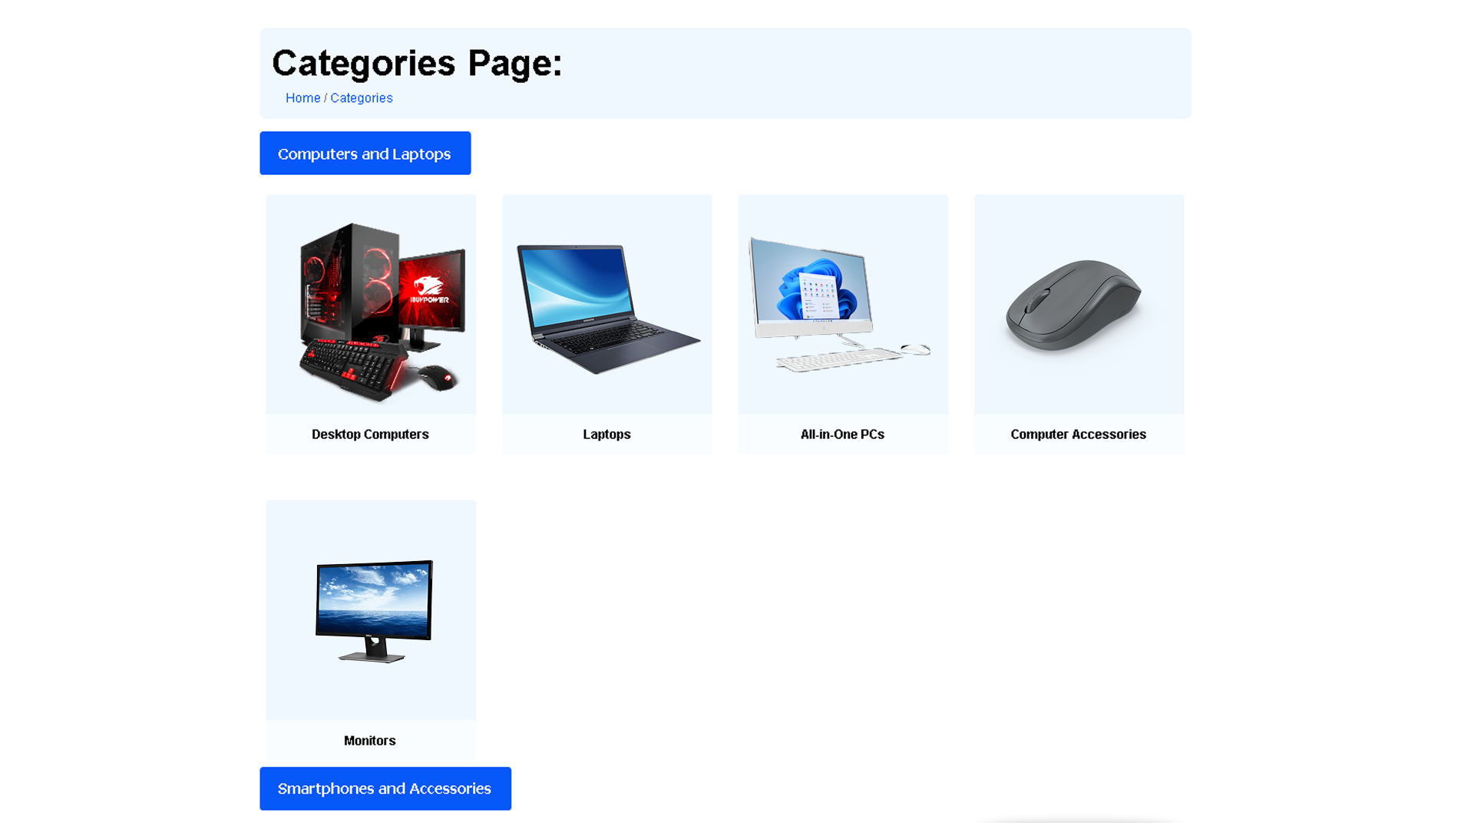

The Categories Page at Electro-X is a meticulously curated digital directory, providing users with an organised and comprehensive view of our diverse electronic product offerings. It's your passport to an extensive world of tech wonders. Here, you'll find our product categories neatly arranged, ranging from smartphones to gaming gear, and everything in between.

Each category is a portal to explore a specific niche of electronics. Whether you're seeking the latest smartphones or diving into the realm of gaming, this page ensures easy navigation. You can filter and sort products to find precisely what you're looking for, saving you valuable time.

Our Categories Page is designed with user-friendliness in mind, ensuring a seamless and enjoyable shopping experience. It's a reflection of our commitment to providing a one-stop destination for electronic enthusiasts. At Electro-X, we're dedicated to making your tech dreams come true, and our Categories Page is your first step towards that digital adventure.

# Sub Categories Page

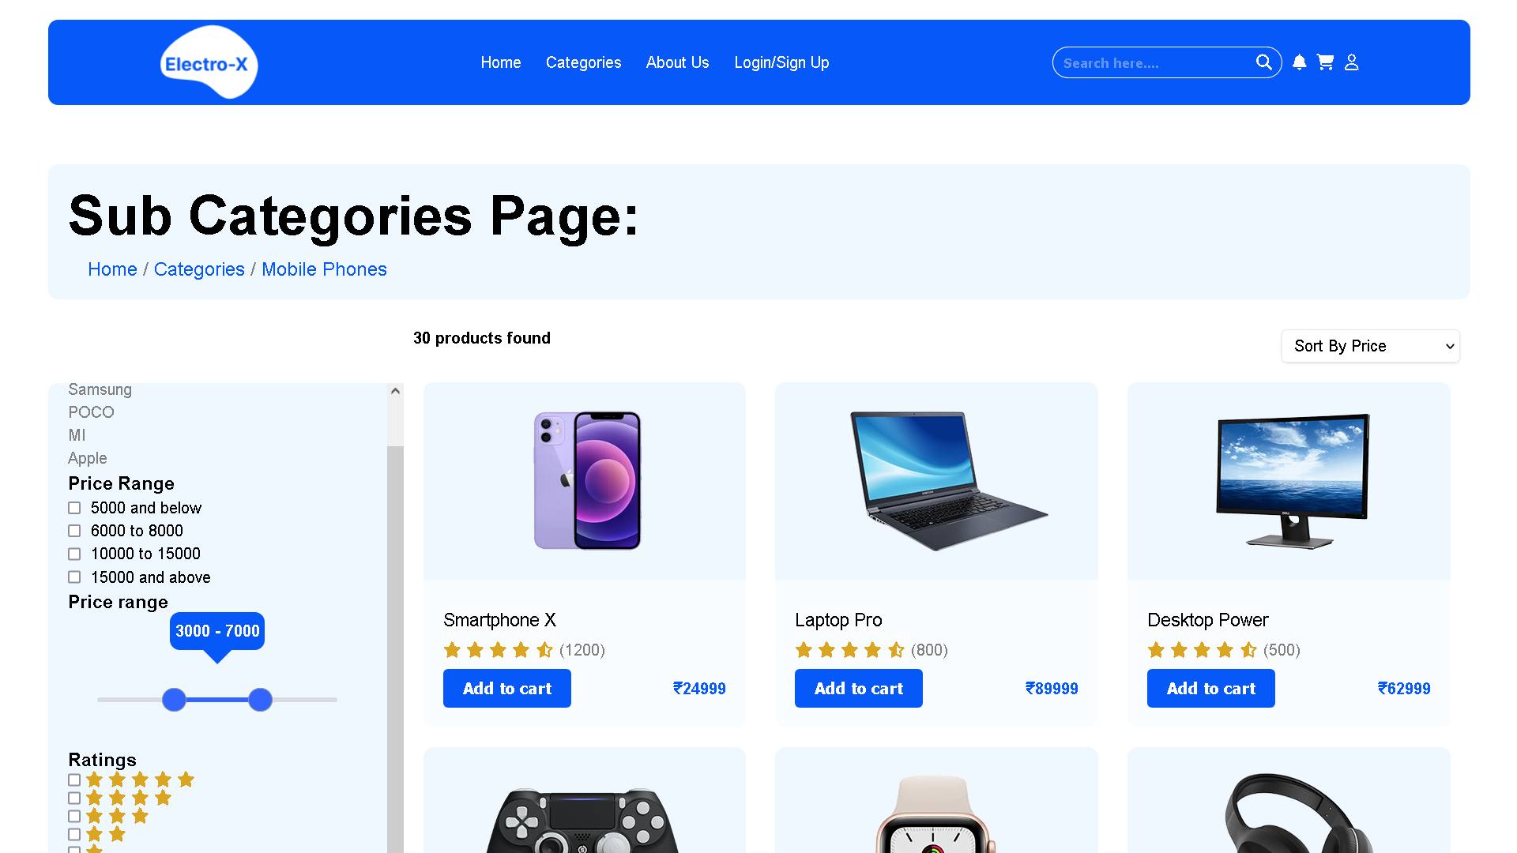

The Subcategories Page at Electro-X takes your electronic shopping journey to the next level. Here, you'll find an extensive array of subcategories that delve deeper into specific niches within our product offerings. Whether you're a tech aficionado or simply searching for something specific, this page provides a more refined and detailed experience.

Our subcategories include a diverse range of options, from smartphone accessories to gaming peripherals, enabling you to explore the minutiae of your electronic interests. However, what truly sets this page apart is the built-in filter feature. With just a few clicks, you can narrow down your search by factors like price range, brand, or product specifications.

The filter functionality redirects you to a dedicated Filter Page, where you can fine-tune your preferences. This intuitive system ensures that you find precisely what you're looking for, saving you time and simplifying your shopping experience.

At Electro-X, our Subcategories Page and Filter functionality work in harmony to empower you, the customer, with precision and convenience in your quest for the perfect electronic products. It's all about making your tech dreams come true, one click at a time.

# Demo Page

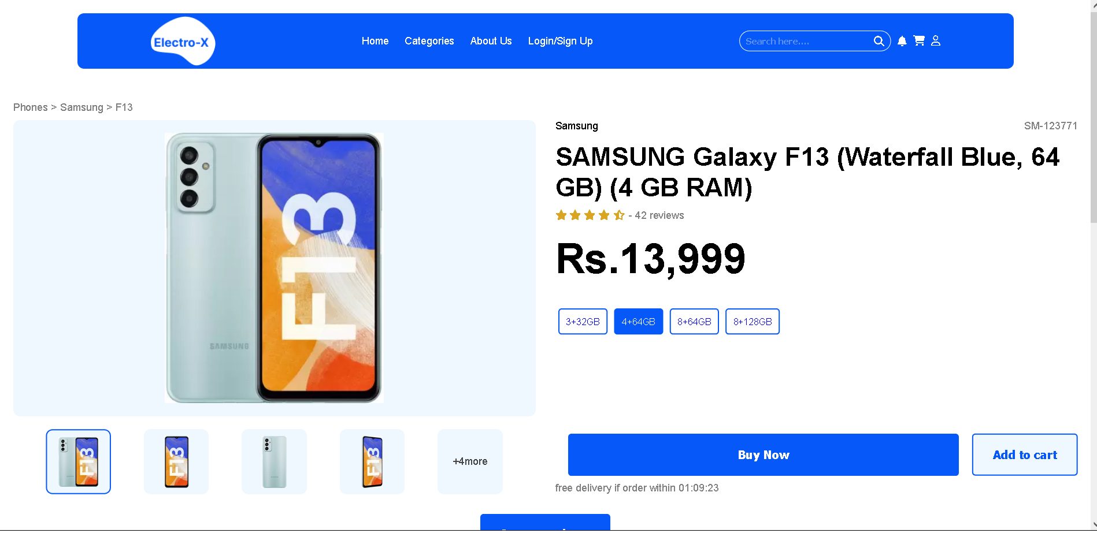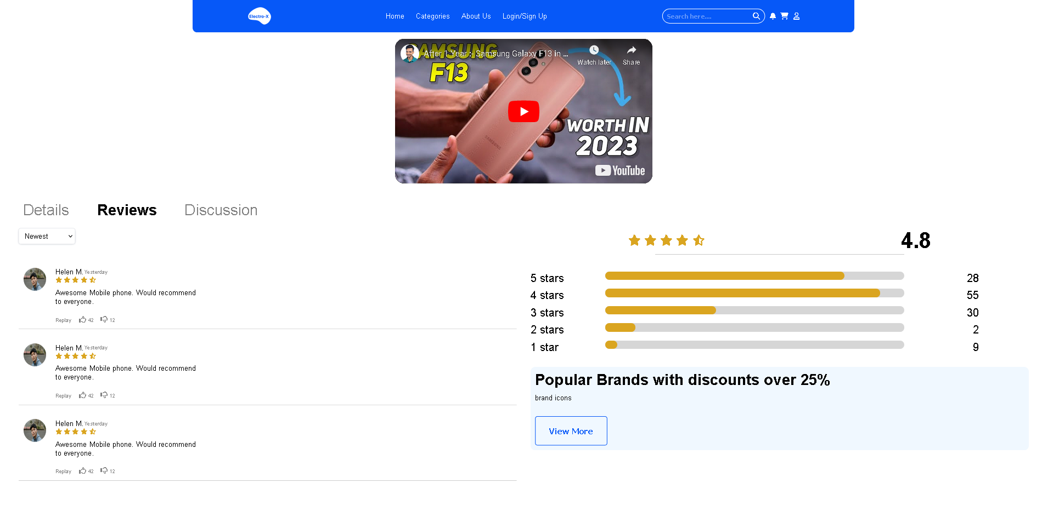

The Demo Page at Electro-X is your go-to resource for a comprehensive understanding of our products. We believe in informed choices, and this page is designed to empower you with all the information you need before making a purchase. Here's what you'll find on our Demo Page:

Product Reviews and Ratings: We provide a platform for customers to share their experiences through detailed reviews. You can read about real-life usage, performance, and overall satisfaction. Our star ratings system further condenses these insights, giving you a quick overview of a product's popularity and quality.

Pricing Information: Our Demo Page includes transparent pricing details, ensuring you're fully aware of the cost before making a decision. We believe in honesty and clarity when it comes to the financial aspect of your purchase.

Demo Videos: To enhance your understanding, we offer informative demo videos for each product. These videos guide you through the features, functions, and practical usage of the item. They provide a visual walkthrough, making it easier for you to decide if a product aligns with your needs.

At Electro-X, we're dedicated to providing a well-rounded shopping experience, and our Demo Page is a testament to that commitment. It's your gateway to informed and confident decision-making, allowing you to explore products with the depth of information you deserve.

# Login/ SignUp Page

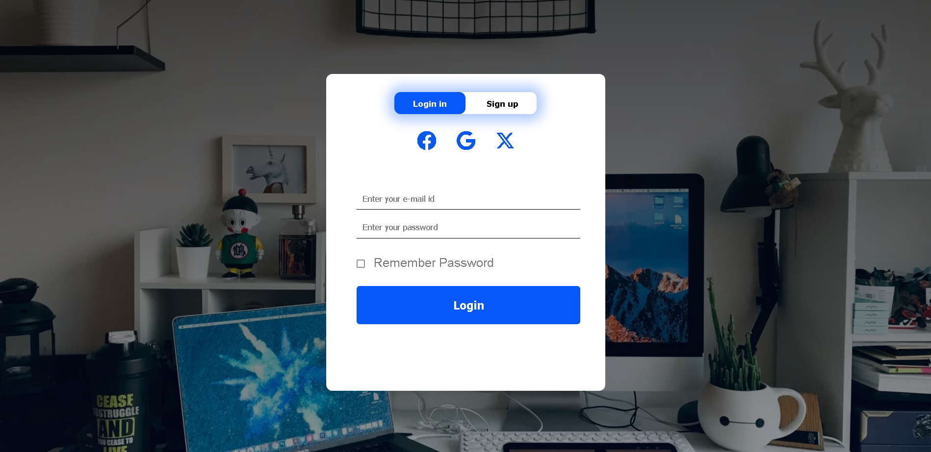

# Filter Page(for 6-8k price filter)

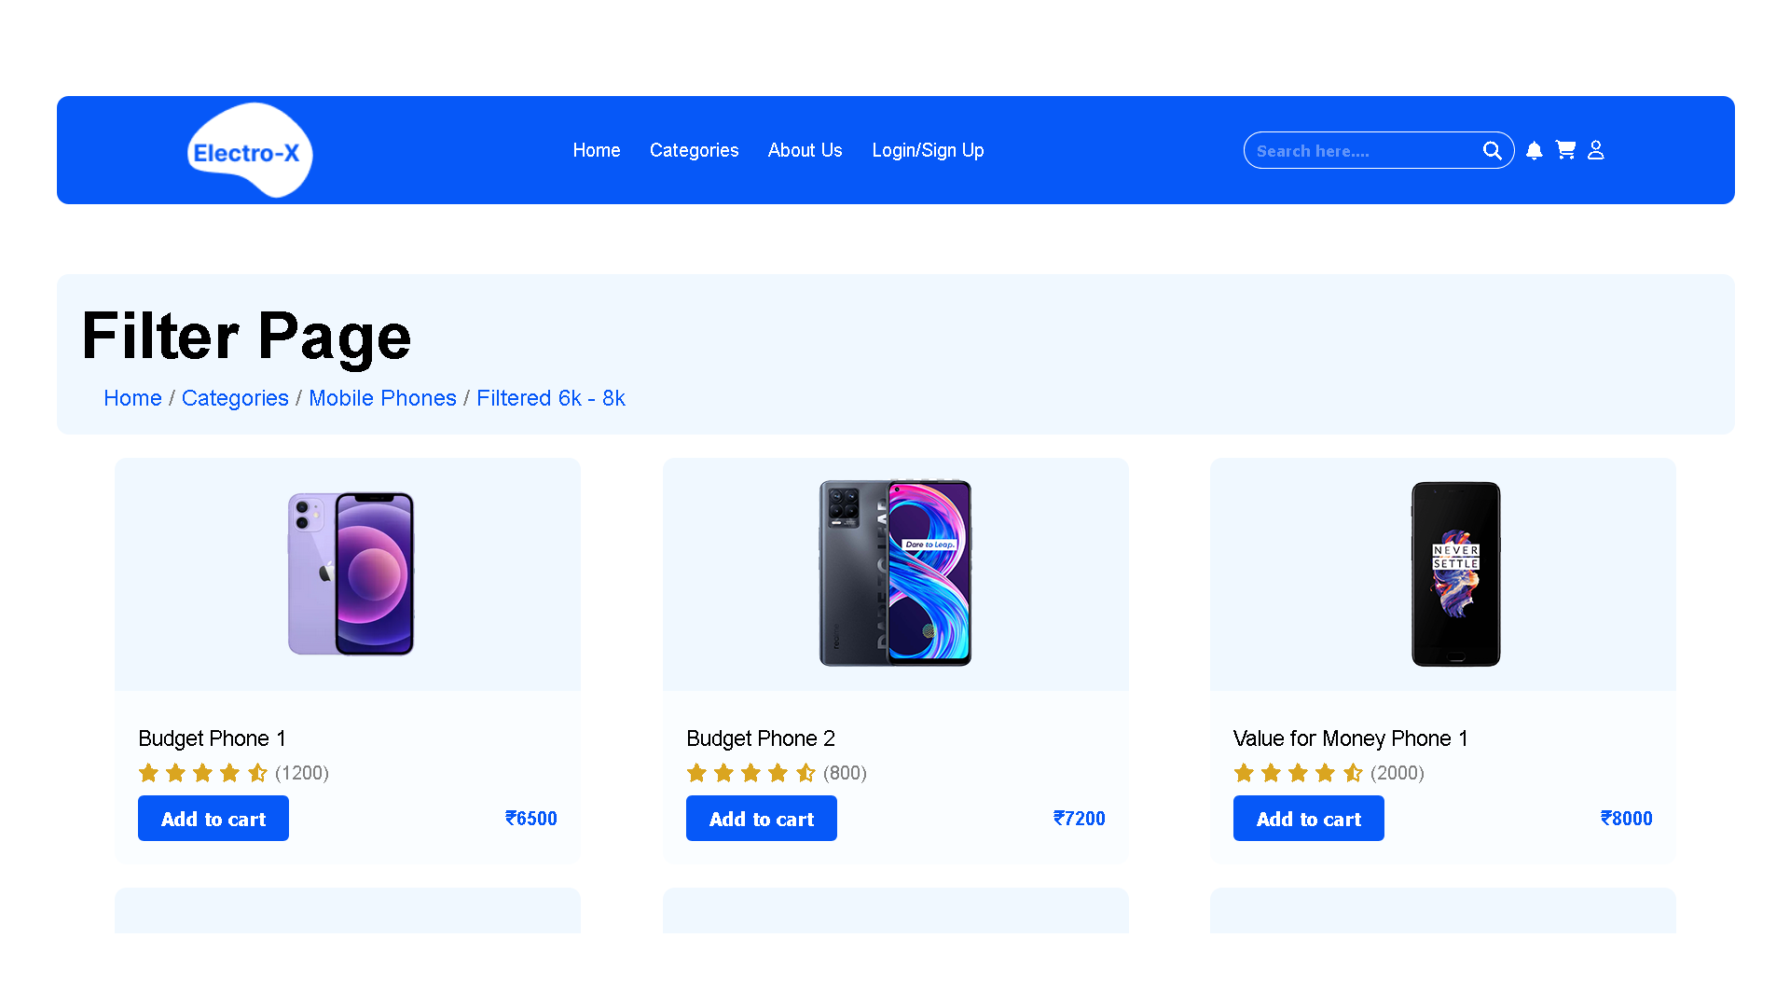

The Price Filter Page at Electro-X is your tool for pinpointing affordable options that match your budget and requirements. When you select the price range of 6 to 8 thousand, you'll find a curated selection of smartphones that provide great value without breaking the bank. These devices combine quality, features, and affordability, ensuring that you can enjoy the latest technology without exceeding your budget. The filter page streamlines your search, presenting you with a range of choices tailored to your financial parameters. It's all about simplifying the shopping process, making sure you find the perfect phone that meets both your needs and your budget.

# Filter Page(for 10-15k price filter)

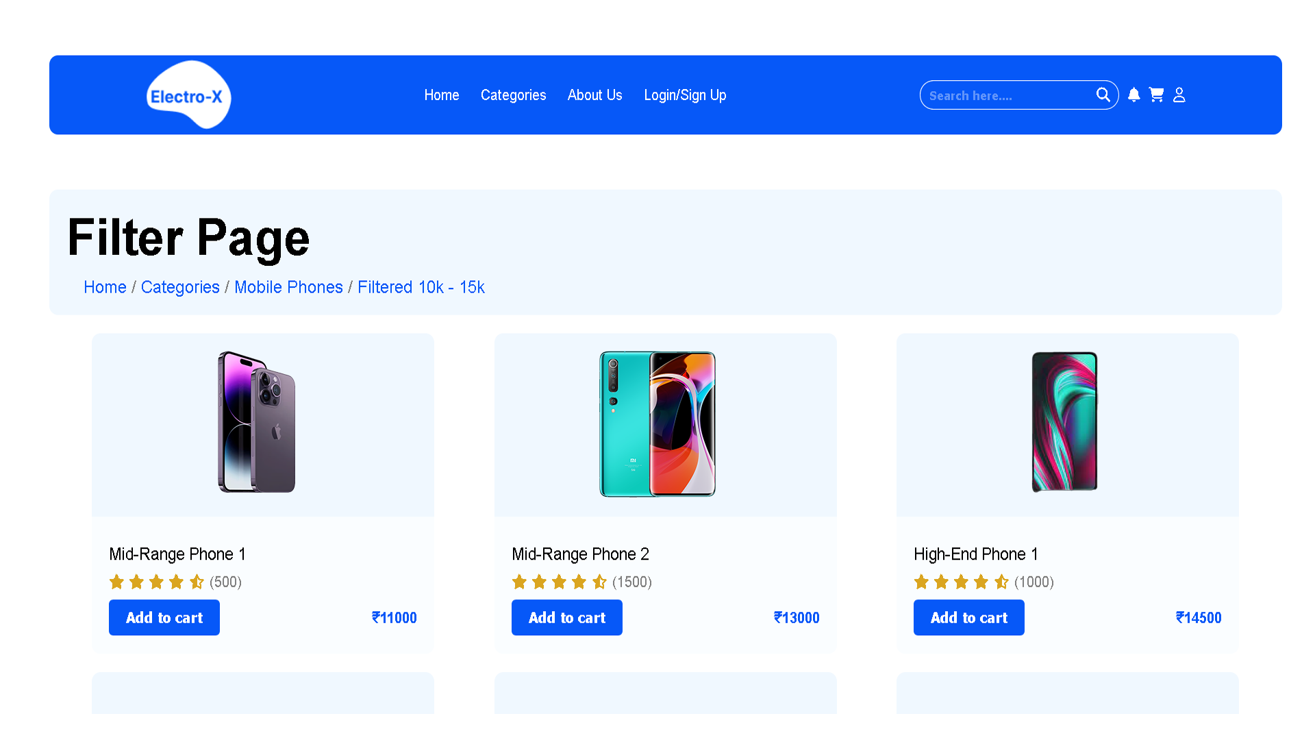

The Price Filter Page at Electro-X offers a carefully selected range of smartphones in the price bracket of 10,000 to 15,000. Here, you'll discover a collection of devices that strike the perfect balance between affordability and advanced features. These smartphones are known for their excellent performance, camera quality, and overall user experience, making them an ideal choice for those seeking great value without compromising on functionality. The filter page streamlines your search, ensuring that you're presented with a variety of options tailored to your specific budget. Whether you're a tech enthusiast or just looking for a reliable phone, this price range provides the best of both worlds – a cost-effective solution without sacrificing the quality and features you desire.

# Search Page

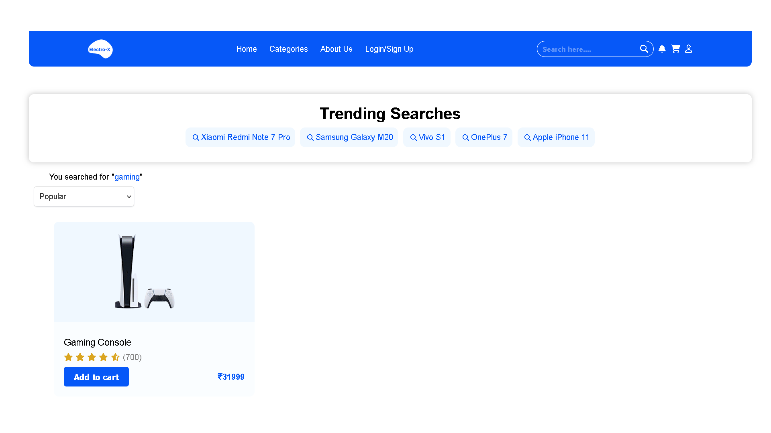

The Search Page at Electro-X is your gateway to discovering the electronic products you desire with ease and precision. We understand that every customer is unique, with specific needs and preferences, and that's why our search feature is here to simplify your shopping experience.

Our robust search engine empowers you to swiftly and effectively explore our extensive product catalogue. Whether you're searching for a specific smartphone model, a particular gaming accessory, or any other electronic item, you can simply enter keywords or phrases into the search bar. The results are generated in real-time, offering you a comprehensive list of products that match your query.

We believe in providing a seamless and efficient shopping experience, and our Search Page is a reflection of that commitment. It ensures that you can effortlessly find the electronic items you desire, saving you time and effort while delivering the satisfaction of finding the perfect product. At Electro-X, we're dedicated to putting the power of choice at your fingertips.

# Cart Page

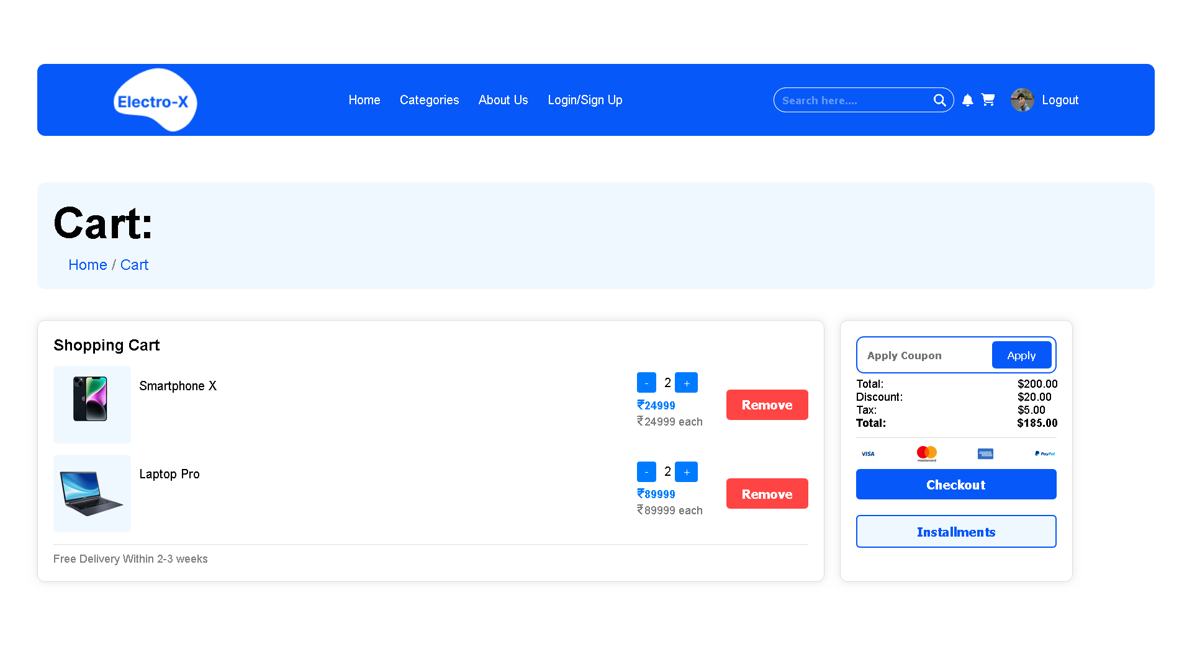

The Cart Page at Electro-X is your personal shopping assistant, simplifying the process of collecting and managing the electronic products you've chosen. It's an essential component of your shopping journey, ensuring a convenient and efficient experience.

Here's what you can expect from our Cart Page:

Product Organisation: As you browse our extensive catalogue, you can effortlessly add items to your cart with a single click. The Cart Page serves as a digital basket where you can neatly organise your selections, ensuring you don't miss out on any desired products.

Quantity Control: You have complete control over the quantity of each item in your cart. Adjust the quantity according to your needs before proceeding to checkout.

Price Summary: The Cart Page provides a detailed summary of your selected products, including individual prices and the total cost. It offers transparency, so you're always aware of your purchase's financial implications.

Checkout Convenience: Once you're ready to complete your purchase, our Cart Page seamlessly guides you to the checkout process, streamlining your journey from selection to ownership.

In summary, our Cart Page is your trusted companion, ensuring a hassle-free shopping experience. It lets you assemble your electronic wishlist and proceed to checkout with ease, making Electro-X your ultimate destination for all things tech.

# Checkout Page

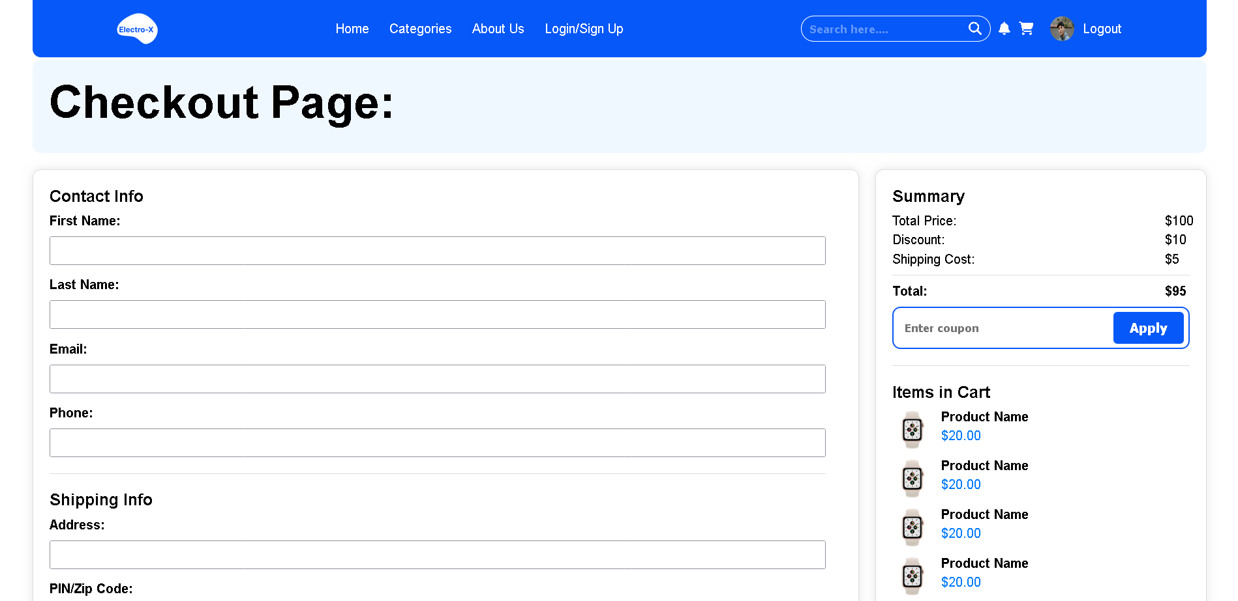

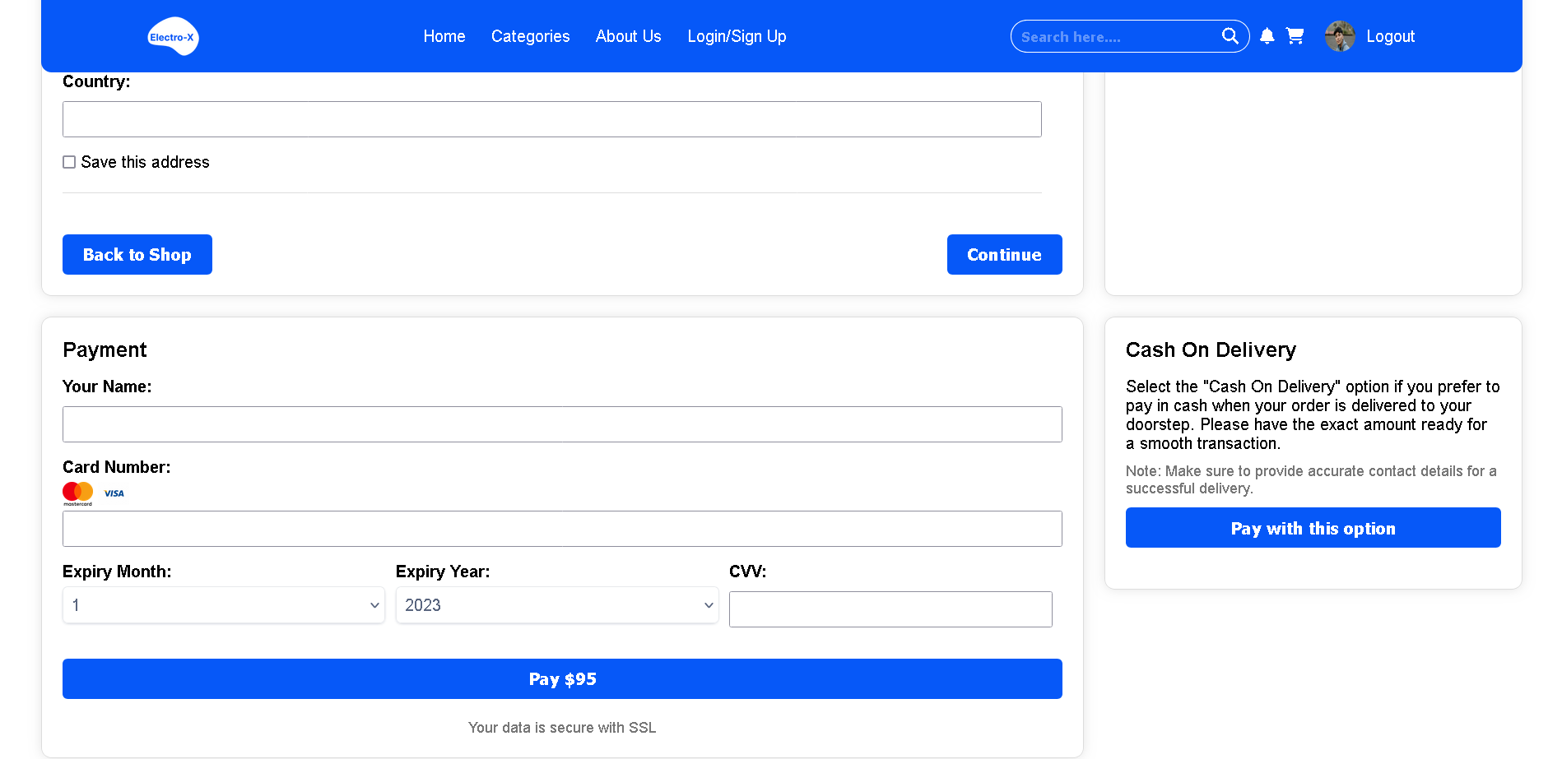

The Checkout Page at Electro-X is the final stop on your exciting journey to acquire the latest and greatest in electronic products. It's a seamless and secure platform designed to ensure a smooth transition from selection to ownership.

Here, you'll find all the tools you need to complete your purchase effortlessly. It's where you can review your chosen items, modify quantities, and confirm the total cost before finalising the transaction. Our user-friendly interface makes entering shipping and payment information a breeze, and multiple secure payment options are available to suit your preferences.

We prioritise security, employing encryption and safety measures to protect your personal data and financial information. Your trust is of utmost importance to us, and our Checkout Page is designed to reflect that commitment. So, whether you're shopping for the latest smartphone or high-end gaming gear, the Electro-X Checkout Page is your gateway to owning the tech products you love, with convenience and peace of mind.

# User Profile Page

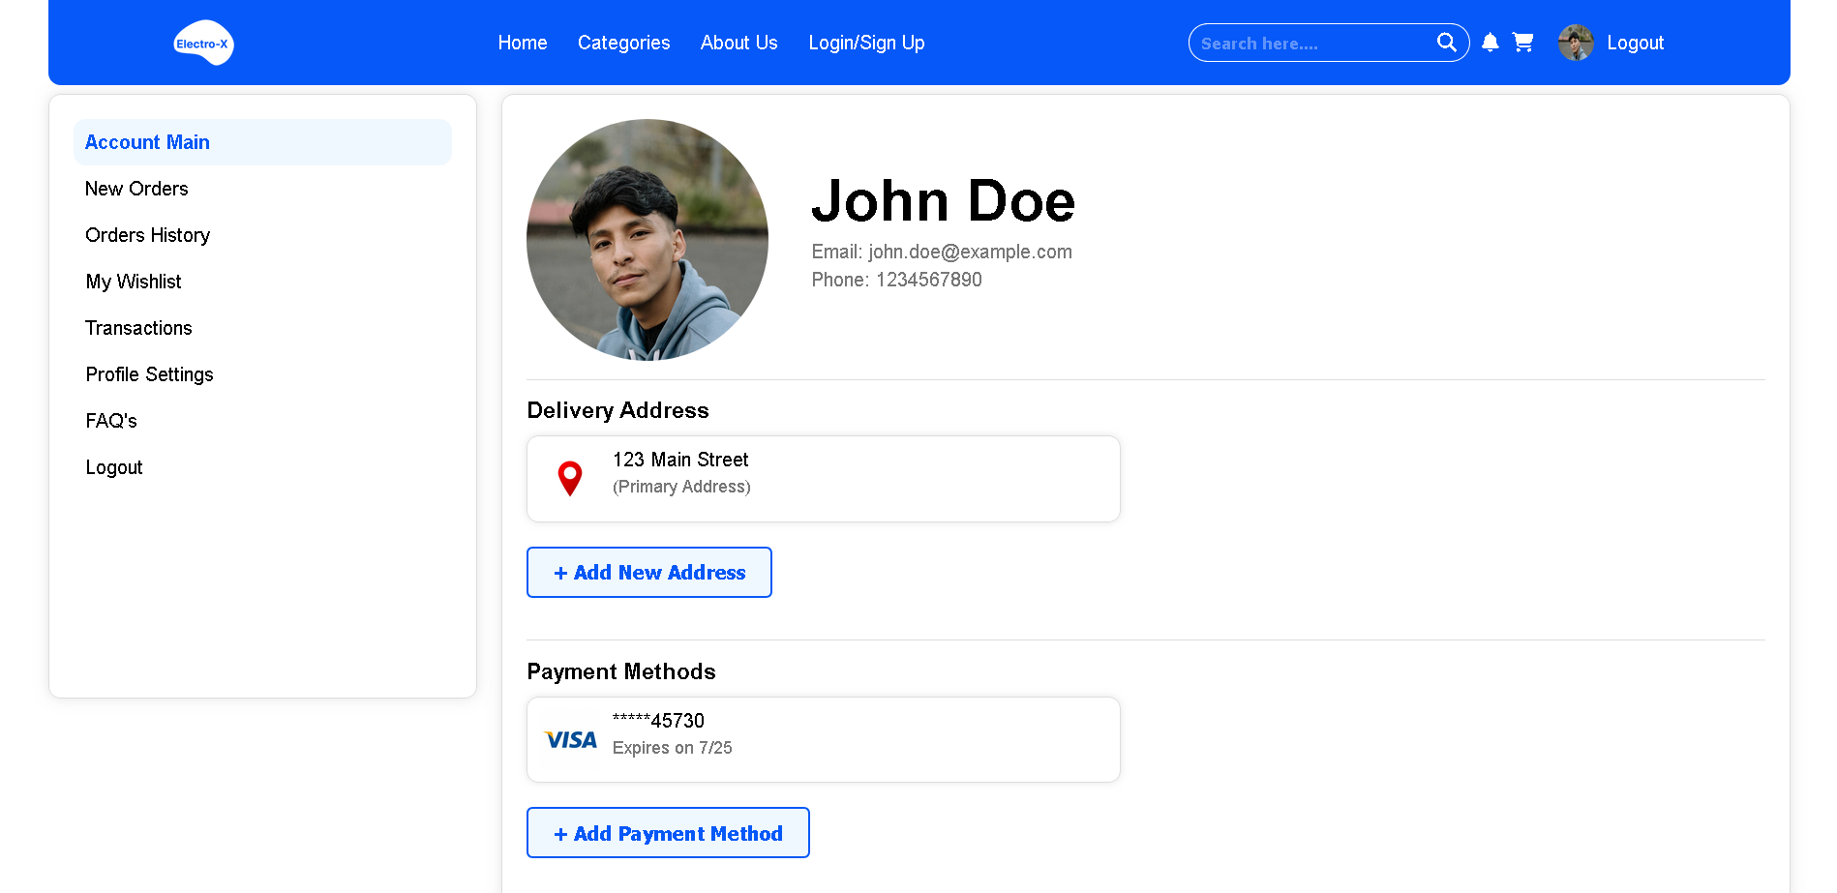

The User Profile Page at Electro-X is your personal hub for managing your account details, making your shopping experience more flexible and convenient. This feature allows you to tailor your account to your specific needs and preferences.

Here's what you can expect from our User Profile Page:

Address Management: You have the flexibility to add, edit, or delete shipping addresses. This feature is particularly useful if you want your orders delivered to different locations, or if you need to update your primary address.

Payment Methods: Managing your payment methods has never been easier. You can securely add, edit, or remove credit cards, debit cards, or other payment options. This flexibility ensures a smooth and seamless checkout process.

Profile Information: View and modify your account details, including your name, email address, and contact information. This ensures that your profile is always up-to-date.

By offering these features, we empower you to personalise your shopping experience. The User Profile Page is all about flexibility, convenience, and keeping your information accurate and secure. Whether you're exploring the latest tech or updating your account details, Electro-X puts the control in your hands.

# New Orders Page

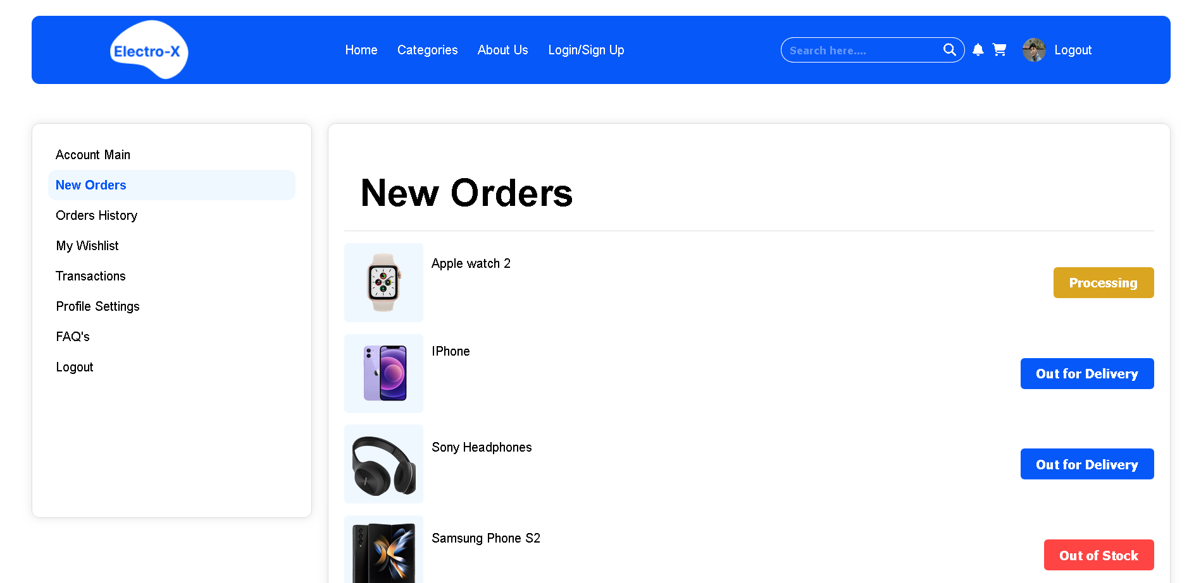

The New Orders Page at Electro-X is your real-time window into the status of your recent electronic product purchases. It's a vital feature that keeps you informed about the progress of your orders, ensuring transparency and peace of mind throughout your shopping journey.

Here's what you can expect from our New Orders Page:

Order Status: Our user-friendly interface provides clear and detailed information about the status of each product in your order. You can quickly discern if a product is in stock, out for delivery, or in the processing phase. This real-time status update keeps you in the loop, so you always know the whereabouts of your purchases.

Order Details: In addition to the status, the New Orders Page displays essential order details such as product names, quantities, and expected delivery dates. This allows you to stay organised and plan accordingly.

Contact and Support: Should you have any questions or concerns about your orders, our page provides easy access to customer support and contact information.

Our New Orders Page is designed to make your shopping experience hassle-free and transparent. It empowers you with the information you need to track your orders and make informed decisions about your electronic product purchases. At Electro-X, we believe that an informed and satisfied customer is at the heart of every successful transaction.

# Order History Page

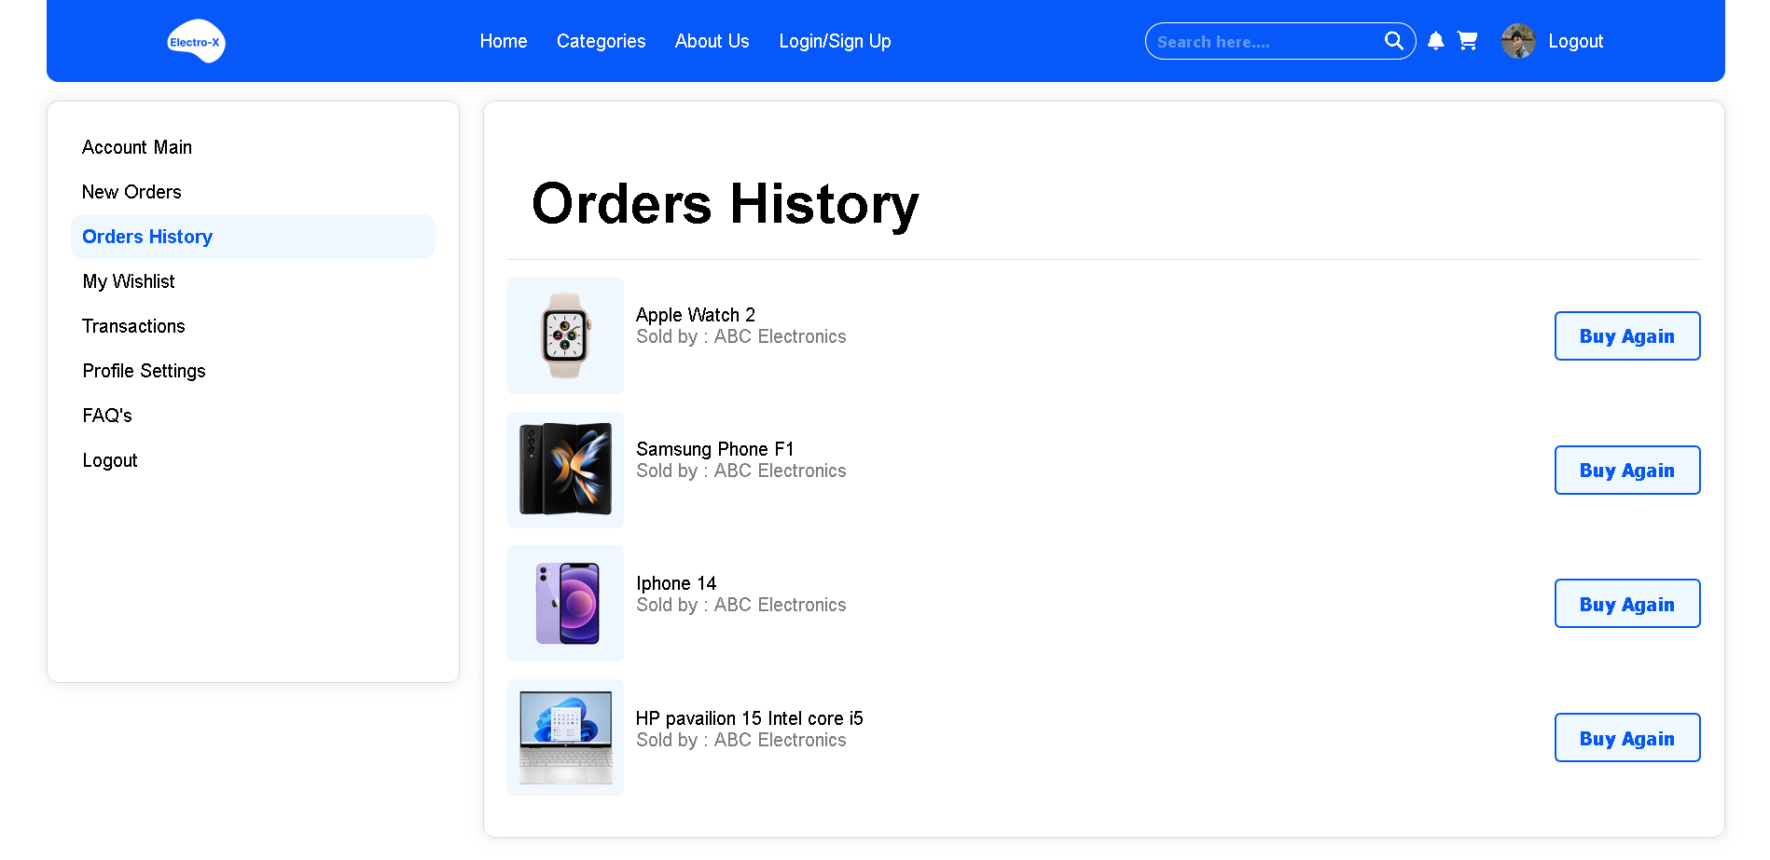

The Order History Page at Electro-X is your digital record book, chronicling your journey of electronic product acquisitions. It's a valuable feature that offers a comprehensive view of your past orders, providing a sense of organisation and reference as you continue to explore the world of tech.

Here's what you can expect from our Order History Page:

Order Archive: The page compiles a complete archive of all your past purchases, listing each order along with the date of purchase, order number, and order total. It's your one-stop destination to track your shopping history.

Detailed Receipts: By clicking on a specific order, you can access detailed receipts, giving you an itemised breakdown of your purchases, including product names, quantities, prices, and any applicable discounts.

Reorder Convenience: For your convenience, the Order History Page allows you to quickly reorder the same products, making it easy to repurchase your favourite electronic items.

Tracking Information: If a product had a delivery associated with it, you can easily access tracking information to check the status of past deliveries.

Our Order History Page serves as a digital filing cabinet for your electronic product transactions. It offers clarity, organisation, and easy access to past orders, empowering you to make informed decisions and effortlessly revisit your tech shopping history. At Electro-X, we believe that a well-documented order history is key to a seamless and satisfying shopping experience.

# Transaction Page

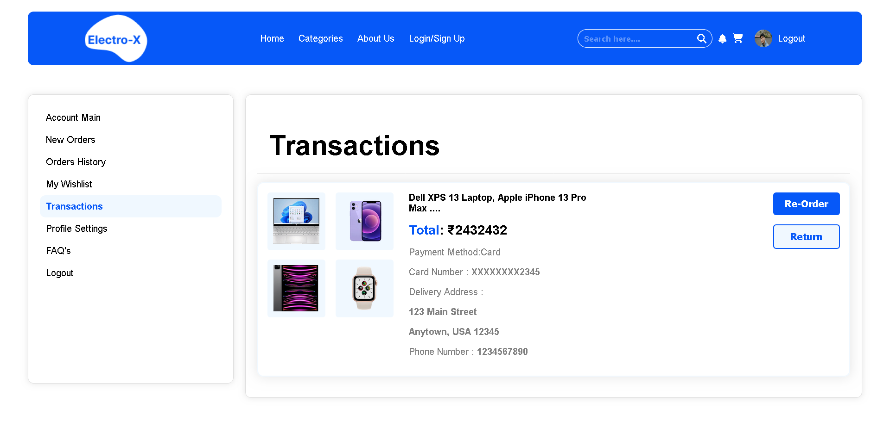

The Transaction Page at Electro-X is your financial compass, offering a detailed overview of your electronic product purchases and payments. This page plays a crucial role in maintaining transparency and financial control as you navigate the world of tech.

Here's what you can expect from our Transaction Page:

Payment History: Our Transaction Page provides a comprehensive history of your payments, listing each transaction along with the date, payment method, and amount. It ensures that you have a clear record of your financial interactions with Electro-X.

Invoice Access: By selecting a specific transaction, you can access detailed invoices, complete with a breakdown of products purchased, prices, taxes, and order numbers. This feature allows you to review the specifics of each transaction at a glance.

Receipts and Statements: You can conveniently download and save receipts and statements for your records, making it easy to track and manage your financial history.

Support and Assistance: Should you have any questions or concerns about a transaction, our page provides easy access to customer support and contact information.

Our Transaction Page is designed to provide you with a robust financial record, ensuring that you can keep track of your expenses and payments with confidence. Electro-X values transparency and accountability, and this page is a testament to our commitment to your financial well-being as you explore the world of technology.

# Wishlist Page

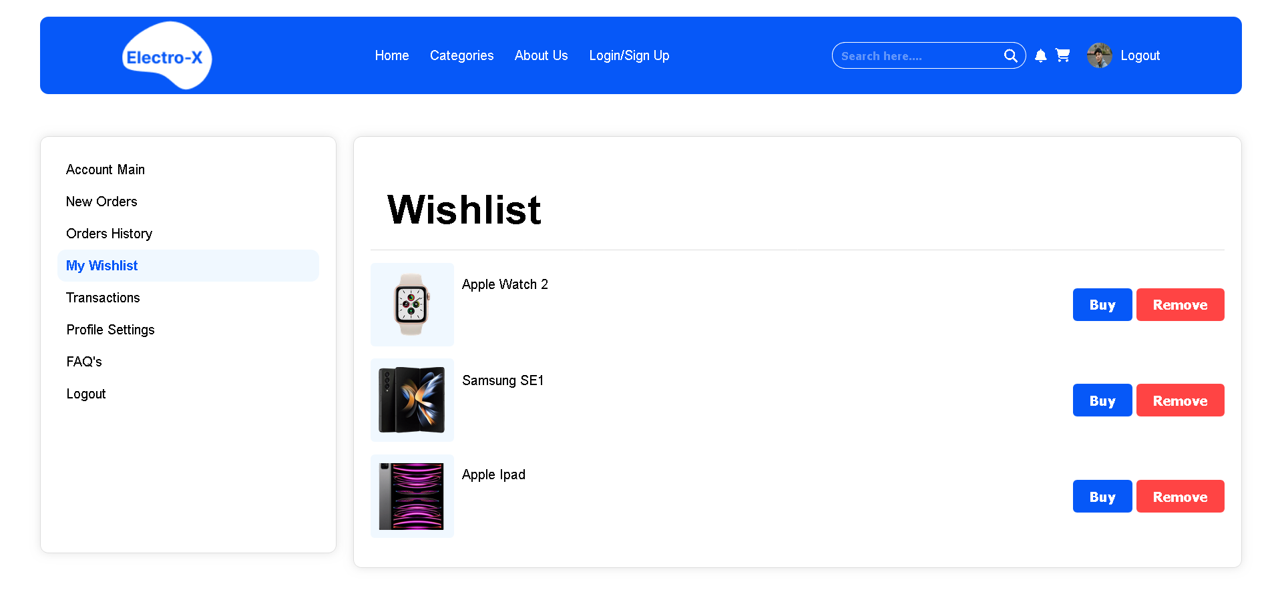

The Wishlist Page at Electro-X is your virtual treasure trove of coveted electronic products. It's a personalised space where you can save, organise, and dream about your favourite tech items, whether you're ready to purchase them or simply exploring your options.

Here's what you can expect from our Wishlist Page:

Product Collection: The Wishlist Page is where you can gather and save electronic products that catch your eye. Whether it's a cutting-edge smartphone, a gaming console, or any other tech gadget, you can add it to your wishlist with a single click.

Organization and Prioritization: You have the freedom to organise your wishlist, creating categories or notes to help you remember why you added a particular item. It's a space where you can prioritise and plan your future purchases.

Notification Alerts: The wishlist is more than just a digital notepad; it's also a helpful tool for staying updated. You'll receive notifications when there are price drops or special offers on items in your wishlist.

Quick Access: The Wishlist Page provides convenient access to your saved products, making it easy to compare, review, and decide when you're ready to make a purchase.

Our Wishlist Page is all about personalization and making your tech dreams come true. It's a place where you can curate your future electronic adventures, saving and tracking the products that pique your interest. Whether you're building your dream setup or just exploring, Electro-X ensures that your wishlist is your gateway to the world of tech possibilities.

# Profile Setting Page

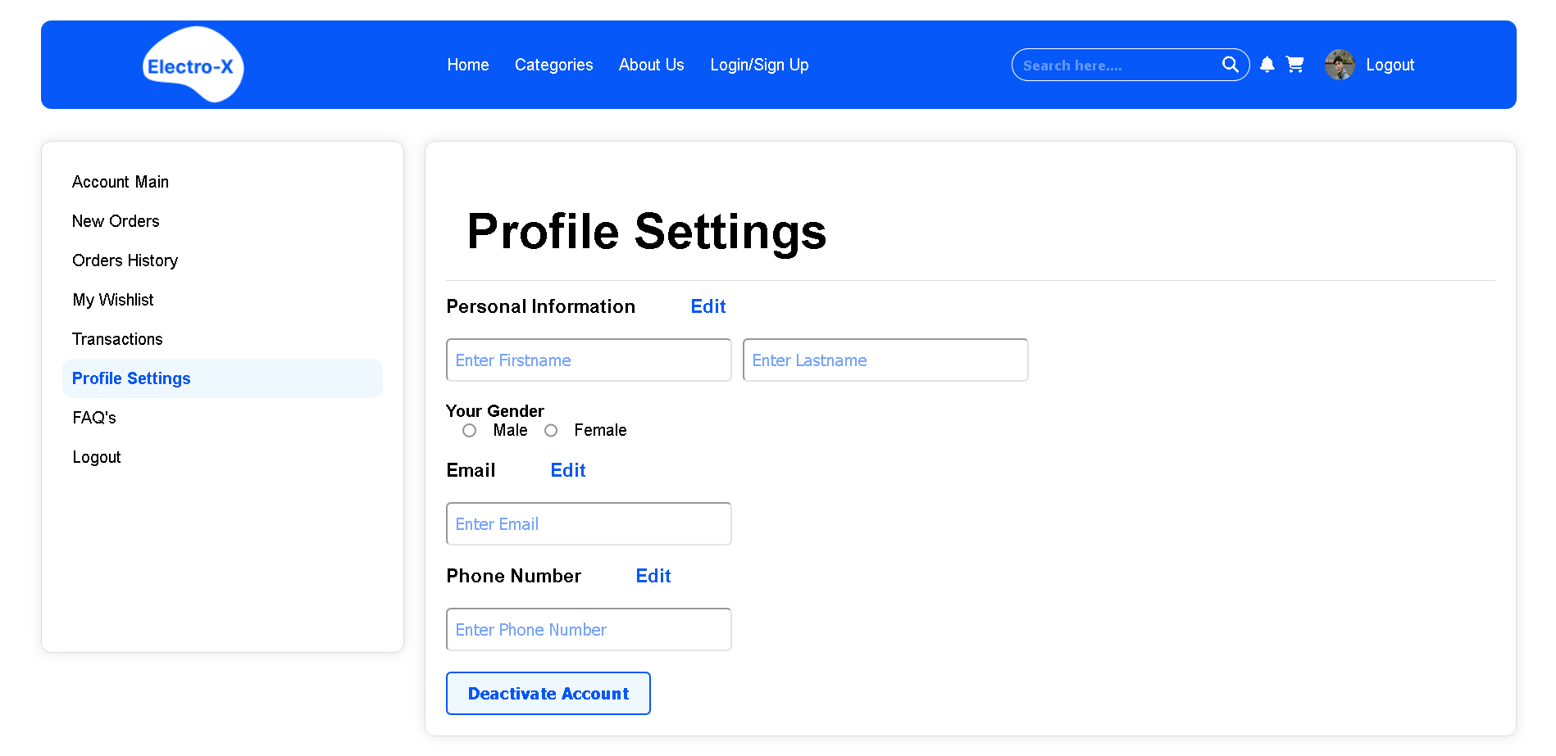

The Profile Settings Page at Electro-X is your command centre for managing your account and tailoring your online experience to your preferences. This versatile page allows you to customise various aspects of your profile and ensures that you have control over your interactions with our platform.

Here's what you can expect from our Profile Settings Page:

Account Information: You can easily update your name, email address, or contact details, keeping your account information accurate and up to date.

Password Management: For security purposes, you can change your password to enhance your account's safety and privacy.

Deactivation Option: In case you decide to take a break or explore other options, you have the ability to deactivate your account temporarily or permanently.

Email Preferences: You can set your email preferences, choosing which notifications and updates you wish to receive from Electro-X. This feature allows you to customise your email communication to suit your needs.

Our Profile Settings Page is all about personalization and control. It empowers you to manage your account information, stay connected the way you prefer, and maintain the security and privacy of your online presence. Electro-X values your individuality and ensures that your experience is tailored to your liking, from personal details to email communication preferences.

# Comparison Page

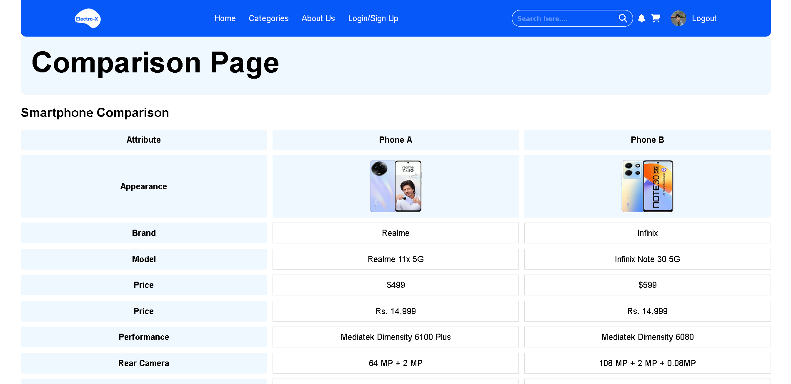

The Comparison Page at Electro-X is your virtual laboratory for evaluating and contrasting electronic products. It's a dynamic tool designed to simplify the decision-making process when you're torn between two or more tech items.

Here's what you can expect from our Comparison Page:

Side-by-Side Analysis: You can select multiple products from our catalogue and place them side by side for a detailed comparison. This feature provides an easy and visual way to see how these items measure up to each other.

Key Specifications: Our page offers a comprehensive breakdown of each product's key specifications, including performance details, features, and pricing. This allows you to pinpoint the differences and similarities between the products.

User Reviews: You can access user reviews and ratings for each product, providing valuable insights into the real-world experiences of other customers. This feature is instrumental in making an informed decision.

Easy Decision-Making: The Comparison Page is all about simplifying the decision-making process. It empowers you to evaluate your options thoroughly, ensuring that you make a well-informed choice that aligns with your needs and preferences.

At Electro-X, we understand that choosing the right electronic product can be a complex decision. Our Comparison Page is designed to provide clarity and guidance, making it easier for you to select the perfect tech item that fits your requirements and expectations. Whether you're shopping for a new smartphone, a laptop, or any other electronic gadget, this page is your invaluable resource for finding the best fit.

# About Us Page

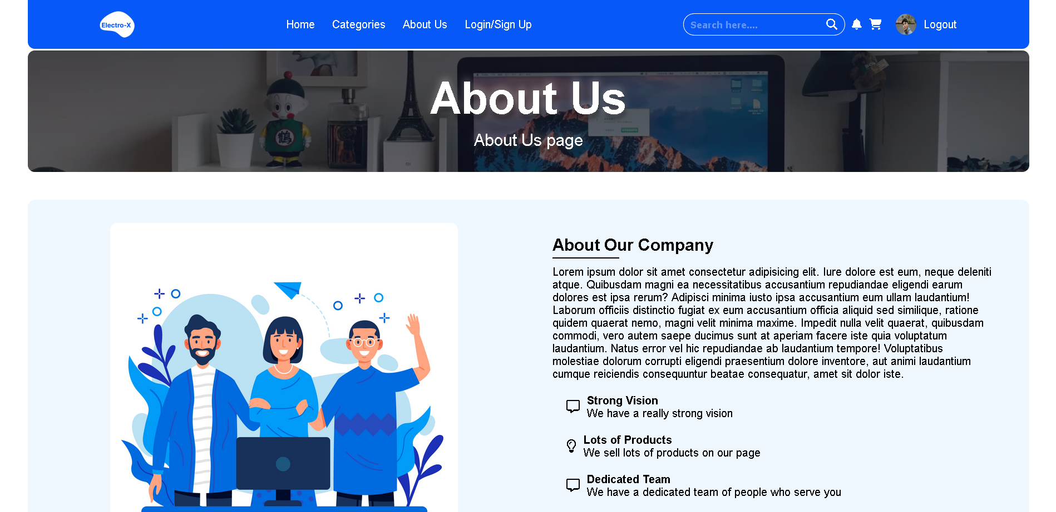

The "About Us" page at Electro-X is the narrative of our journey and values. It's an open book, inviting you to learn more about who we are, what we stand for, and what drives us in the world of technology.

Here's what you can expect from our "About Us" page:

Our Story: This is where we share the origins of Electro-X, our mission, and the passion that fuels our journey. It's a glimpse into our humble beginnings and how we've evolved into the electronic product destination we are today.

Our Values: We're committed to integrity, customer satisfaction, innovation, and quality. Our "About Us" page provides insights into the principles and values that guide our every action.

Our Team: Meet the faces behind Electro-X. We believe in transparency, and introducing our team members, experts in various tech fields, allows you to put a face to the brand.

Our Commitment: This page highlights our dedication to delivering a seamless and satisfying tech shopping experience, backed by our customer-centric approach and commitment to quality.

At Electro-X, we want you to know who you're dealing with. Our "About Us" page is an open declaration of our identity, vision, and what you can expect when you choose us as your technology partner. It's all about building trust and letting you become a part of our tech journey.

# FAQ Page

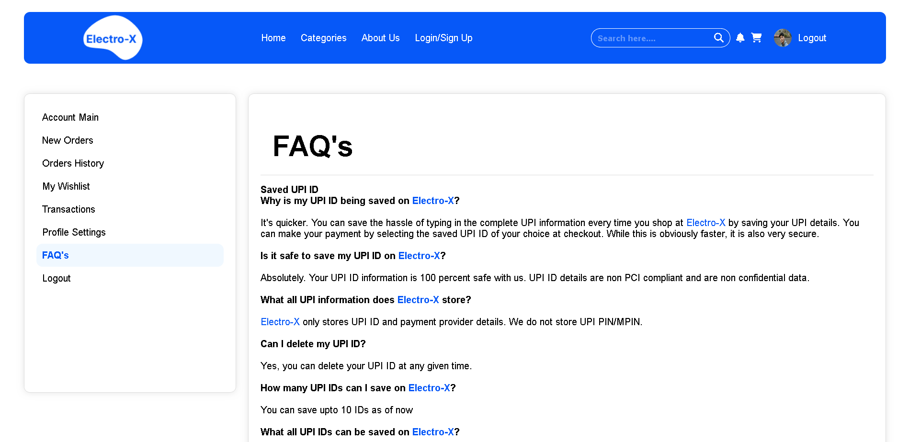

The FAQ (Frequently Asked Questions) Page at Electro-X is your go-to resource for answers to common queries, ensuring that your shopping experience is as smooth and informed as possible. This page serves as a valuable information hub, addressing the most common concerns and inquiries you may have.

Here's what you can expect from our FAQ Page:

Comprehensive Answers: The FAQ page is a repository of responses to the questions most frequently posed by our customers. It covers topics such as order processes, payment methods, shipping, returns, and more.

Quick Resolution: If you have a query or need assistance, the FAQ page is often the quickest way to find an answer. It eliminates the need to wait for customer support and allows you to resolve issues at your convenience.

Ease of Navigation: The FAQ page is organised into categories, making it simple to locate the information you're seeking. You can browse through sections that pertain to your specific inquiry.

Updated Information: We regularly update the FAQ page to ensure that the information remains current and relevant. This means you're always receiving the most accurate and up-to-date answers.

Our FAQ Page is designed to enhance your shopping experience by providing swift access to essential information. It's all about empowering you with knowledge and ensuring that your interactions with Electro-X are as convenient and transparent as possible.

# **Technologies Used**

## **HTML**

HTML (Hypertext Markup Language) is a fundamental technology used in the development of Electro-X for several critical reasons. As the backbone of the World Wide Web, HTML is the standard markup language used to create the structure and content of web pages.

At its core, HTML serves as the skeleton of a webpage, providing the framework for organising and presenting information. It utilises a system of tags and elements to define the structure of a page, including headings, paragraphs, lists, links, and images. This structured approach ensures consistency and clarity in the presentation of content.

HTML's importance in Electro-X extends beyond basic structure. It allows for the integration of other essential technologies, such as CSS (Cascading Style Sheets) and JavaScript, which collectively enable advanced design and interactivity. CSS provides the ability to style and design web content, ensuring a visually appealing and user-friendly interface, while JavaScript adds interactivity and dynamic features.

In summary, HTML is the foundation of Electro-X, serving as the framework upon which we build a cohesive and structured web presence. It is integral in organising and presenting information and serves as the gateway to incorporating other key technologies, ultimately ensuring a seamless and interactive experience for our users.

## **CSS**

CSS (Cascading Style Sheets) is an integral technology in the development of Electro-X for various crucial reasons. CSS plays a pivotal role in enhancing the visual aesthetics, user experience, and overall design of our website.

One of the primary functions of CSS is to provide a consistent and visually pleasing presentation of web content. It allows us to define the layout, colour schemes, fonts, and styling of our web pages, ensuring a uniform and engaging user interface. CSS not only beautifies the website but also creates a sense of cohesion and professionalism.

CSS also facilitates responsive web design, a critical feature in our project. With the diverse range of devices and screen sizes in use today, CSS enables our website to adapt seamlessly to different resolutions. This ensures that users can enjoy an optimal browsing experience, whether on a desktop computer, tablet, or smartphone.

Moreover, CSS supports the creation of engaging and interactive elements, such as hover effects, animations, and transitions, making the user experience more enjoyable and dynamic. It works harmoniously with HTML and JavaScript to create a well-rounded and user-centric website.

In summary, CSS is an essential component in Electro-X that transforms the project from a static framework into an aesthetically appealing, responsive, and interactive platform. It elevates the design, ensures consistency, and adapts to various devices, ultimately enhancing the user experience on our website.

## **Javascript**

JavaScript is a cornerstone technology in the development of Electro-X, offering a dynamic and interactive dimension to our website. Here's why we use JavaScript and its significance in our project:

Interactivity: JavaScript empowers us to create interactive elements and dynamic features on our website. It enhances user engagement by enabling real-time actions, such as product filtering, instant search results, and interactive forms. This interactivity elevates the user experience, making Electro-X more engaging and user-friendly.

Client-Side Functionality: As a client-side scripting language, JavaScript runs directly in a user's web browser. This not only reduces the workload on the server but also speeds up website performance by offloading certain processes to the user's device. It contributes to a smoother and more responsive user experience.

Data Handling: JavaScript is adept at handling data in real-time. It allows us to update product information, cart contents, and user preferences without requiring page refreshes. This real-time data management is pivotal in delivering a seamless and efficient shopping experience.

Third-Party Integrations: JavaScript facilitates the integration of third-party services and tools, enhancing the website's functionality. Whether it's payment gateways, analytics, or social media integrations, JavaScript enables us to seamlessly incorporate these services into Electro-X.

In summary, JavaScript is an indispensable technology in our project. It breathes life into the website, adding interactivity and dynamic features that are essential for modern e-commerce. It enhances the user experience, optimises performance, and allows for real-time data handling, ensuring that Electro-X is a robust, engaging, and user-centric platform.

# **Key Features**

## **Protected Routes**

Implementing protected routes that restrict access to certain features, such as the user dashboard and cart management, when a user is not logged in is a crucial aspect of our project's development. The goal is to ensure the security and privacy of user data and interactions while providing a seamless and user-friendly experience for registered users.

Protected routes were challenging to implement as they required a careful balance between user security and convenience. It was essential to create a system that allowed registered users to access their dashboard and manage their cart items while preventing unauthorised users from doing so.

To tackle this challenge, we utilised a combination of JavaScript and server-side technologies to manage user sessions and access controls. Users are required to log in before accessing their dashboard or adding items to their cart. This login requirement ensures that only authorised users can engage with these features.

Our system employs robust authentication and authorization mechanisms to verify user credentials and control access to specific routes. For unauthorised users, the system redirects them to the login or registration page, ensuring a smooth transition into protected areas once they've logged in.

The implementation of protected routes exemplifies our commitment to user security and data privacy. It provides a safeguard for user information while maintaining a user-friendly and convenient experience for registered users. It's a testament to our dedication to creating a secure and enjoyable online environment for our users.

## **Cart functionality**

Implementing protected routes for the cart feature, ensuring that only logged-in users can add items to their cart, posed a significant challenge during our project's development. The primary objective was to create a secure and personalised shopping experience while preventing unauthorised access to a user's cart and maintaining the privacy of their selections.

This challenge involved establishing a system that allowed registered users to interact with their cart, including adding and managing items, while ensuring that unauthorised users couldn't access this personal information.

To address this challenge, we employed a combination of JavaScript and server-side technologies to manage user sessions and access controls. Users are required to log in to their accounts before they can add items to their cart. This authentication process verifies the user's identity and prevents unauthorised access.

Our system uses robust authorization mechanisms to regulate access to specific cart-related routes. For unauthorised users, the system redirects them to the login or registration page, ensuring a smooth transition to cart access once they've successfully logged in.

The implementation of protected routes for the cart feature underlines our commitment to safeguarding user data and privacy. It ensures that only authorised users have control over their shopping cart, maintaining the confidentiality of their selections while delivering a secure and seamless shopping experience.

## **Search functionality**

The search functionality is a standout feature of our website, designed to provide users with a quick and efficient way to find the electronic products they're looking for. Whether you're hunting for a specific smartphone model or browsing through various laptop options, our search feature streamlines the process and ensures a user-friendly experience.

Key aspects of our search functionality include:

Effortless Discovery: Users can simply enter keywords or product names into the search bar, and our system will return real-time, relevant results. This feature is designed for ease of use, allowing you to quickly explore our extensive product catalogue.

Advanced Filters: To further refine your search, we offer a range of filters and sorting options. You can narrow down results based on product attributes, price ranges, brands, and more. This empowers you to pinpoint exactly what you're looking for.

Quick Navigation: The search results are presented in a user-friendly layout, with product images and brief descriptions, making it easy to identify the right items at a glance.

Responsive Performance: Our search feature is optimised for speed and responsiveness, ensuring that even with a diverse and extensive product selection, you can access results in a matter of moments.

The search functionality is a core component of our website, tailored to enhance your shopping experience. It ensures that you can efficiently explore and discover the electronic products that match your needs and preferences, making your visit to Electro-X productive and enjoyable.

## **Range Filter**

The range filter is a versatile and user-centric feature of our website, designed to empower users to narrow down their product searches based on specific price ranges. This functionality is a valuable tool that enables users to find electronic products that align with their budget and preferences.

By implementing the range filter, users can define their own price boundaries and explore products that fall within those limits. This flexibility allows for a tailored shopping experience, where you can easily discover items that match your financial considerations.

Moreover, the range filter is seamlessly integrated into our website's search and category pages, making it accessible and intuitive. Users can effortlessly set their preferred price range using interactive sliders or input fields, providing an immediate and visually pleasing way to narrow down their options.

The range filter feature is a testament to our commitment to user satisfaction and convenience. It's designed to enhance your shopping experience by ensuring that you have complete control over your budget, making it easier than ever to discover the electronic products that fit your needs while adhering to your financial preferences.

# **Project Timeline**

## **August**

During the month of August, our project's primary focus will revolve around the foundational phases of development. This includes the exciting phase of design conceptualization, where we'll ideate and envision the website's look and feel. We will engage in mockup creation, crafting visual representations of the website's layout and aesthetics. Additionally, August will see us delve into the intricate task of developing the HTML structure, which serves as the cornerstone of the entire website.

These initial stages of the project are crucial as they set the tone for the entire development process. We aim to establish a solid foundation for the website's visual appearance and structure, ensuring that it aligns with our vision and meets the expectations of our users. This meticulous approach in August will pave the way for a seamless and visually appealing user experience as we progress into the subsequent phases of the project.

## **September**

The month of September marks a pivotal stage in our project's development journey. During this dedicated period, our primary focus will be the integration of Cascading Style Sheets (CSS) into our project. CSS is the magic wand that transforms the structural HTML framework into an aesthetically pleasing and cohesive design.

Throughout September, our skilled team will work diligently to add styles to the HTML structure, ensuring a harmonious and visually captivating user interface. We believe that a well-crafted design not only enhances the overall aesthetics of the website but also plays a fundamental role in user engagement and satisfaction. As such, we are committed to meticulous attention to detail, from typography choices to colour schemes, to create a compelling and consistent design language.

Moreover, responsive design principles will be a core element of our September efforts. This means that the website will be crafted to adapt seamlessly to a diverse range of screen sizes and devices. In an era of mobile technology and varying screen resolutions, ensuring that our website looks and functions flawlessly on every platform is of paramount importance.

As we delve into September, our mission is to harmoniously blend art and technology. The integration of CSS and the application of responsive design principles will not only make the website visually striking but also user-friendly, catering to the needs of our diverse audience. Our commitment to excellence and user-centric design ensures that your experience with Electro-X will be both visually appealing and exceptionally functional.

## 

## **October**

October signifies a pivotal phase in our project's evolution, where the spotlight turns to JavaScript integration. This month-long endeavour is all about infusing interactivity and dynamism into the website, which not only elevates the user experience but also introduces a new dimension of functionality.

Our skilled development team will be hard at work during October, crafting and embedding interactive elements that breathe life into the website. Whether it's creating dynamic product sliders, responsive forms, or seamless navigation menus, JavaScript serves as the engine that powers these functionalities.

In addition to adding these interactive features, October will be a time for rigorous testing and debugging. Our commitment to delivering a seamless and error-free experience for our users is unwavering. Each line of code will be meticulously examined, and thorough testing will be carried out to identify and rectify any potential issues.

By the end of October, our website will have undergone a remarkable transformation. It will be more than a static page – it will be a dynamic, responsive, and engaging platform where users can explore, interact, and experience electronic products in an entirely new way. Our dedication to excellence in design and functionality ensures that your visit to Electro-X will be a rewarding and user-centric experience.

# Challenges and Solution:

## **Making Animated Nav bar**

Creating the animated navigation bar posed a stimulating challenge during the project's development. The aim was to design a navigation bar that not only looked visually appealing but also delivered a seamless and engaging user experience.

The challenge lay in crafting a navigation bar that transitioned smoothly between states, providing clear and intuitive navigation while maintaining a polished, modern appearance. This required a deep understanding of CSS and JavaScript to implement the animations and transitions effectively.

To tackle this challenge, we began with thorough research, exploring various animation libraries and frameworks to identify the most suitable approach. After extensive testing and prototyping, we settled on a combination of CSS animations and JavaScript event handling.

Through careful coding and relentless testing, we achieved a fluid, responsive, and visually striking animated navigation bar. User feedback and iterative refinements played a crucial role in fine-tuning the animation, ensuring that it not only met our design objectives but also enhanced the overall user experience.

In the end, overcoming this challenge was a testament to our team's dedication to delivering a website that seamlessly blends technology and aesthetics, resulting in a dynamic and captivating navigation bar that enhances user engagement.

## **Implementing Cart Feature**

The implementation of the cart feature presented a significant challenge during the project's development. The goal was to create a seamless and user-friendly cart system that allowed users to add, modify, and remove items effortlessly while providing real-time updates on their selections.

The challenge in this task was ensuring that the cart remained responsive, maintaining consistency across various devices and screen sizes. It required intricate JavaScript programming to manage the cart's dynamic behaviour and ensure that it interacted flawlessly with the rest of the website.

To tackle this challenge, our development team engaged in in-depth research, exploring various cart management solutions and examining industry best practices. We then embarked on extensive prototyping and testing to create a custom cart system tailored to our website's unique needs.

By leveraging JavaScript and responsive design principles, we successfully implemented a cart feature that not only met but exceeded our expectations. The cart allows users to manage their selections intuitively and provides a real-time summary of their shopping experience.

Through consistent testing and user feedback, we refined the cart feature to ensure that it seamlessly integrated with the website's overall user experience, facilitating a smooth and convenient shopping journey for our customers. The successful implementation of this feature is a testament to our commitment to providing a cutting-edge, user-centric e-commerce platform.

## **Implementing Login/Sign Up feature**

Integrating the login and logout features presented a fundamental challenge in our project's development. The objective was to create a secure and user-friendly authentication system that allowed users to access their accounts with ease, while also providing robust protection of their personal information.

The challenge here was in ensuring that the login process was both secure and straightforward, with clear error handling for any login issues. Additionally, we needed to implement a seamless logout process that effectively ended the user's session and maintained the privacy and security of their account.

To tackle this challenge, we started by conducting a thorough review of industry-standard authentication practices, as security was a top priority. We incorporated encryption and security protocols to protect user data during login and account management. We also implemented user-friendly interfaces to make the login and logout processes as intuitive as possible.

Throughout the development process, we continually conducted security audits, penetration testing, and user testing to ensure the system's robustness. We also incorporated multi-factor authentication options to provide an extra layer of security for users who wanted it.

The successful implementation of the login and logout features was a result of our unwavering commitment to security and usability. It's a testament to our dedication to providing a safe and user-friendly platform for our customers, ensuring their online experience is not only convenient but also highly secure.

## **Implementing the Nav bar wrapper on Every Page**

Implementing a navigation bar wrapper on every page using JavaScript introduced an interesting challenge during our project's development. The goal was to create a consistent and responsive navigation bar that remained uniform across all pages, providing a seamless and user-friendly browsing experience.

The challenge was to ensure that the wrapper dynamically adapted to different pages, displaying the appropriate navigation links and responsive behaviour based on the content and context of each page.

To tackle this challenge, our development team employed JavaScript to build a dynamic wrapper that fetched and loaded the navigation bar based on the specific page's requirements. We used JavaScript to identify the user's current page, fetch the relevant navigation links and styles, and seamlessly integrate them into the wrapper. This way, users could navigate the website with a consistent experience, regardless of the page they were on.

Iterative testing and responsive design principles were instrumental in fine-tuning the wrapper to ensure that it provided a seamless and cohesive navigation experience. This feature also allowed for easy updates and maintenance, as any changes made to the navigation bar would automatically reflect across all pages.

The successful implementation of the navigation bar wrapper using JavaScript was a demonstration of our commitment to delivering a user-centric and cohesive user experience. It ensured that our website's navigation remained reliable and intuitive, enhancing overall usability and user satisfaction.

## 

# **Conclusion**

In the journey of developing Electro-X, we embarked on a mission to create a cutting-edge e-commerce platform specialising in electronic products. Through meticulous planning, dedicated teamwork, and the integration of essential technologies, we have achieved this goal. Electro-X stands as a testament to our commitment to providing a user-centric, engaging, and secure environment for tech enthusiasts and shoppers.

The foundation of Electro-X is built upon the trio of HTML, CSS, and JavaScript. HTML provides the structural framework, CSS adds the layer of design and interactivity, and JavaScript brings dynamism and responsiveness. These technologies work in harmony to ensure a seamless and visually appealing user experience. We have not only embraced these technologies but harnessed their potential to craft a website that is both functional and aesthetically pleasing.

We have tackled numerous challenges during our project's development, from designing an animated navigation bar to implementing protected routes for user security. These obstacles have strengthened our resolve to deliver a secure, reliable, and user-friendly platform. They have become stepping stones to innovation and improvement.

One of the standout features of Electro-X is its search functionality, allowing users to discover electronic products effortlessly. With real-time results, advanced filtering, and responsiveness, our search feature exemplifies our commitment to providing convenience and efficiency.

In addition, the range filter empowers users to customize their shopping experience by setting price boundaries, while protected routes ensure that access to certain features is reserved for registered users. This enhances user privacy, security, and personalization.

Our journey through August's design and HTML development, September's CSS integration, and October's JavaScript implementation has been a testament to our dedication to delivering a well-rounded, dynamic, and user-centric website.

Electro-X isn't just a website; it's a promise. It's a promise of quality, innovation, and customer satisfaction. It's a promise to deliver a seamless and engaging experience in the world of electronic products. It's a promise to continue evolving, meeting challenges head-on, and constantly improving.

In conclusion, Electro-X is more than a project; it's an embodiment of our passion for technology and our commitment to our users. It's the culmination of hard work, creativity, and a vision to provide a platform that simplifies and elevates the electronic shopping experience. As we look to the future, our promise remains unwavering: Electro-X will continue to be your go-to destination for all things electronic. Thank you for joining us on this journey.

# **Resources And References**

1. [https://www.w3schools.com/html](https://www.w3schools.com/html/)
2. <https://www.w3schools.com/css>
3. [https://www.w3schools.com/js](https://www.w3schools.com/js/)
4. <https://css-tricks.com>
5. <https://www.cssscript.com>
6. <https://csswizardry.com/2013/01/mindbemding-getting-your-head-round-bem-syntax/>